How the Workshop Module works

You will be submitting your draft lab assignments using a Moodle module called “Workshop”. This module will start out in what is called the “Submission Phase”. The workshop stays in this phase until the due date for the draft. During this phase you will be able to upload the draft of your lab work. After the draft due date, the Workshop will switch to the “Assessment Phase”. During that phase you will review another student’s work and another student will review your work. Finally, the Workshop will switch to the “Grading and Evaluation Phase” in which the instructor or grader will review and possible override the scores. Screen-shots from these phases are shown below.

Submission Phase

When you first click on the Lab Draft link you will see:

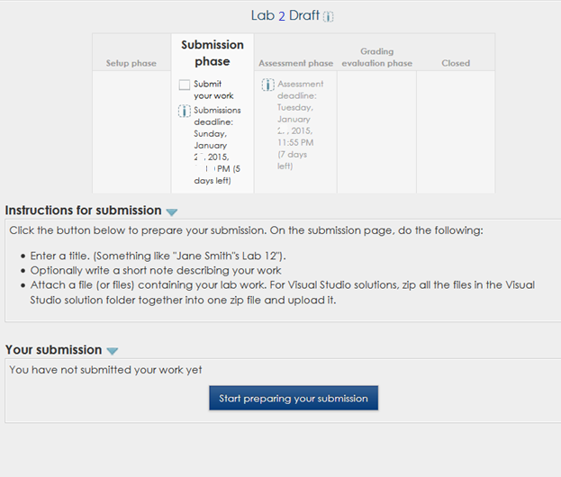

Click on the “Start preparing your submission” button and then you will see the next screen:

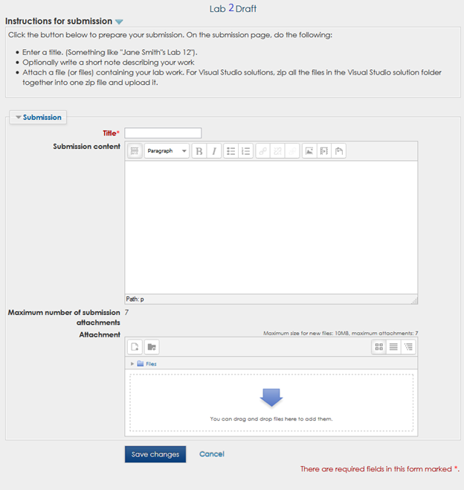

Give your submission a title, attach the files containing your lab work, click the “Save changes” button and you will be done with your submission.

Assessment phase

After the Workshop has been switched to the Assessment phase, when you click on the Lab Draft link, you will see a screen like this:

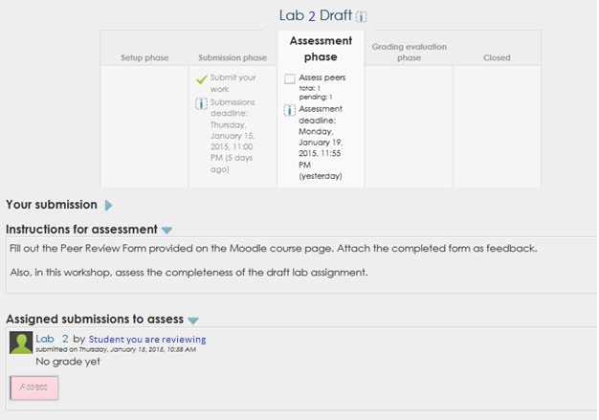

Next, click on the pink Assess button and you will see the following screen:

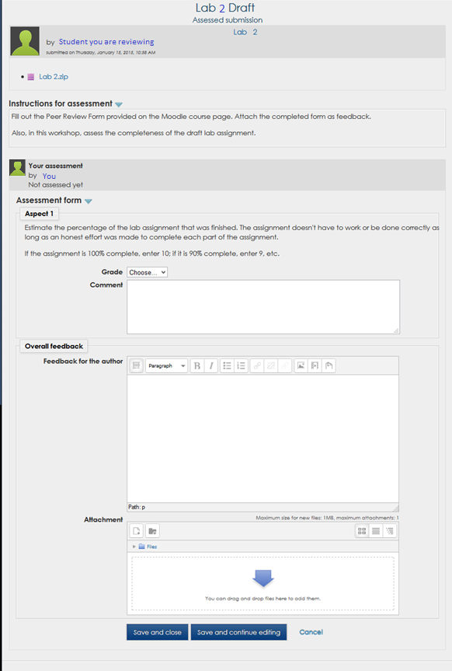

Once you have entered a completeness grade and attached a Peer Review form with the “Draft” column completed, you can click the “Save and close” button and you are done.

Grading and Evaluation Phase

During this phase you will not be able to submit or view assessments. But, once this phase is completed and the workshop shows that it is in the “Closed” phase, you will be able to see the assessment you received.

Closed

The grades will show up in the Moodle gradebook after the instructor has reviewed the submissions and assessments and closed the workshop. Once the workshop is closed, when you click on the Lab Draft link, you will see a screen like the one below:

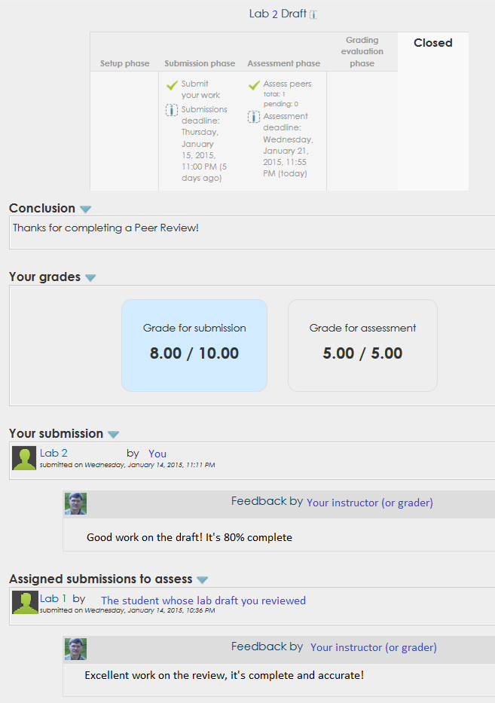

In order to see the assessment from the student who reviewed your work, click on “My submission” in the Navigation column as shown in the screen-shot below:

